**Testing of JT-60SA’s Power Supplies kicks off**

[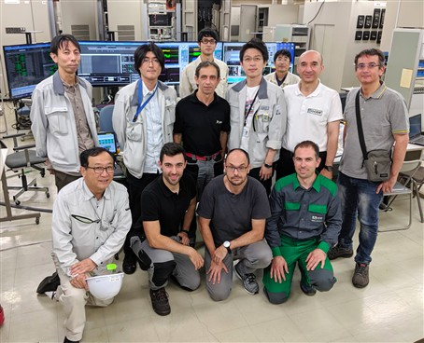](https://f4e.europa.eu/Downloads/News/09_jt60_web-040920191200-Large.jpg)

The team comprising of F4E, QST and industrial suppliers carrying out the testing of the combined operation of JT-60SA's Power Supplies.

Testing of the combined operation of JT-60SA's Power Supplies has kicked off. Managed by QST with the support of a testing team comprising of 30 F4E, industrial suppliers and Consorzio RFX experts, these tests are performed on one complete circuit set of power supplies. The results are the basis for verifying that the power supply equipment that F4E has delivered and the power supply components provided by QST work well together and are all able to provide the current and voltage necessary for JT-60SA's 10 Poloidal Field and 18 Toroidal Field superconducting coils to heat the plasma to the required high temperatures and to ensure that the plasma stays in place in the tokamak during the experiments. This combined testing, as it is called, follows the completion of the individual commissioning of all JT-60SA's Power Supply systems.

The circuit of each JT-60SA Poloidal Field coil includes an individual set of power supplies which consist of three parts: a powerful AC/DC converter that provides the high current needed to create the coil's magnetic field; a Switching Network Unit that generates the high voltage needed to turn on the plasma and heat it; and a Quench Protection Circuit which serves to protect the superconducting coil from damage even if it loses its superconducting characteristics during use. All parts come from Europe and are delivered to the JT-60SA project by F4E, but have been procured by BA Voluntary Contributors France and Italy (through CEA, Consorzio RFX and ENEA) and have been manufactured by various different European companies (JEMA, Nidec ASI, OCEM and Poseico).

The testing currently being carried out focuses on investigating one set of power supplies where a dummy coil which is not superconducting is being used. "We separately test the current and the voltage. In JT-60SA, each set of power supplies will provide a current of around 20 kA and a voltage of 1 kV, but as we don't use a superconducting coil when testing, we are rapidly achieving 20 KA supplying only 130 V DC. It's a good basis though to analyse how well the control system is working coordinating the simultaneous operation of all Power Supply systems, as it's the same system which is used in this testing phase which will be used during JT-60SA operation", explains Giampaolo Frello, F4E's Project Manager responsible for following the testing at the JT-60SA site in Naka, Japan. "With the different parts of the power supplies being procured by different entities and being produced by different companies, it's difficult to learn and ensure that they all work together, so the testing team currently following the testing taking place at the JT-60SA site in Naka, is ready to give support in case of problems."

This phase of the testing of the Power Supplies is scheduled to be completed by the end of the year. The following testing phase during the spring of 2020 will involve connecting a set of the power supplies to a superconducting coil, and thus making way to obtaining JT-60SA first plasma in late 2020.